About your instructor
I am a mum of two children, a grandma, and an Early Years’ Teacher. I have worked with babies, toddlers and young children in children’s centres, schools, nurseries, playgroups, and toddler groups for over 20 years.
I trained with IAIM in 2009 and first ran baby massage classes in my role as a Children’s Centre Teacher. I love providing a warm and welcoming environment where parents and babies can experience the benefits of baby massage.
I have now set up my own baby massage business, running classes around Walsall, Dudley, the Black Country, and the West Midlands.
For more information and to book on classes please contact:
Priscilla Trood on 07984 626637
priscilla.meandmybaby@gmail.com
New five-week course starts on
Wed 30th April at 12.30 – 2.00
Coseley Family Hub, Bayer St, WV14 9DS
FREE!
Funded by the YMCA
See website & social media for more details
https://www.iaim.org.uk/profile/priscillatrood/
https://www.facebook.com/priscillatrood/
@me_and_my_baby_pt on Instagram

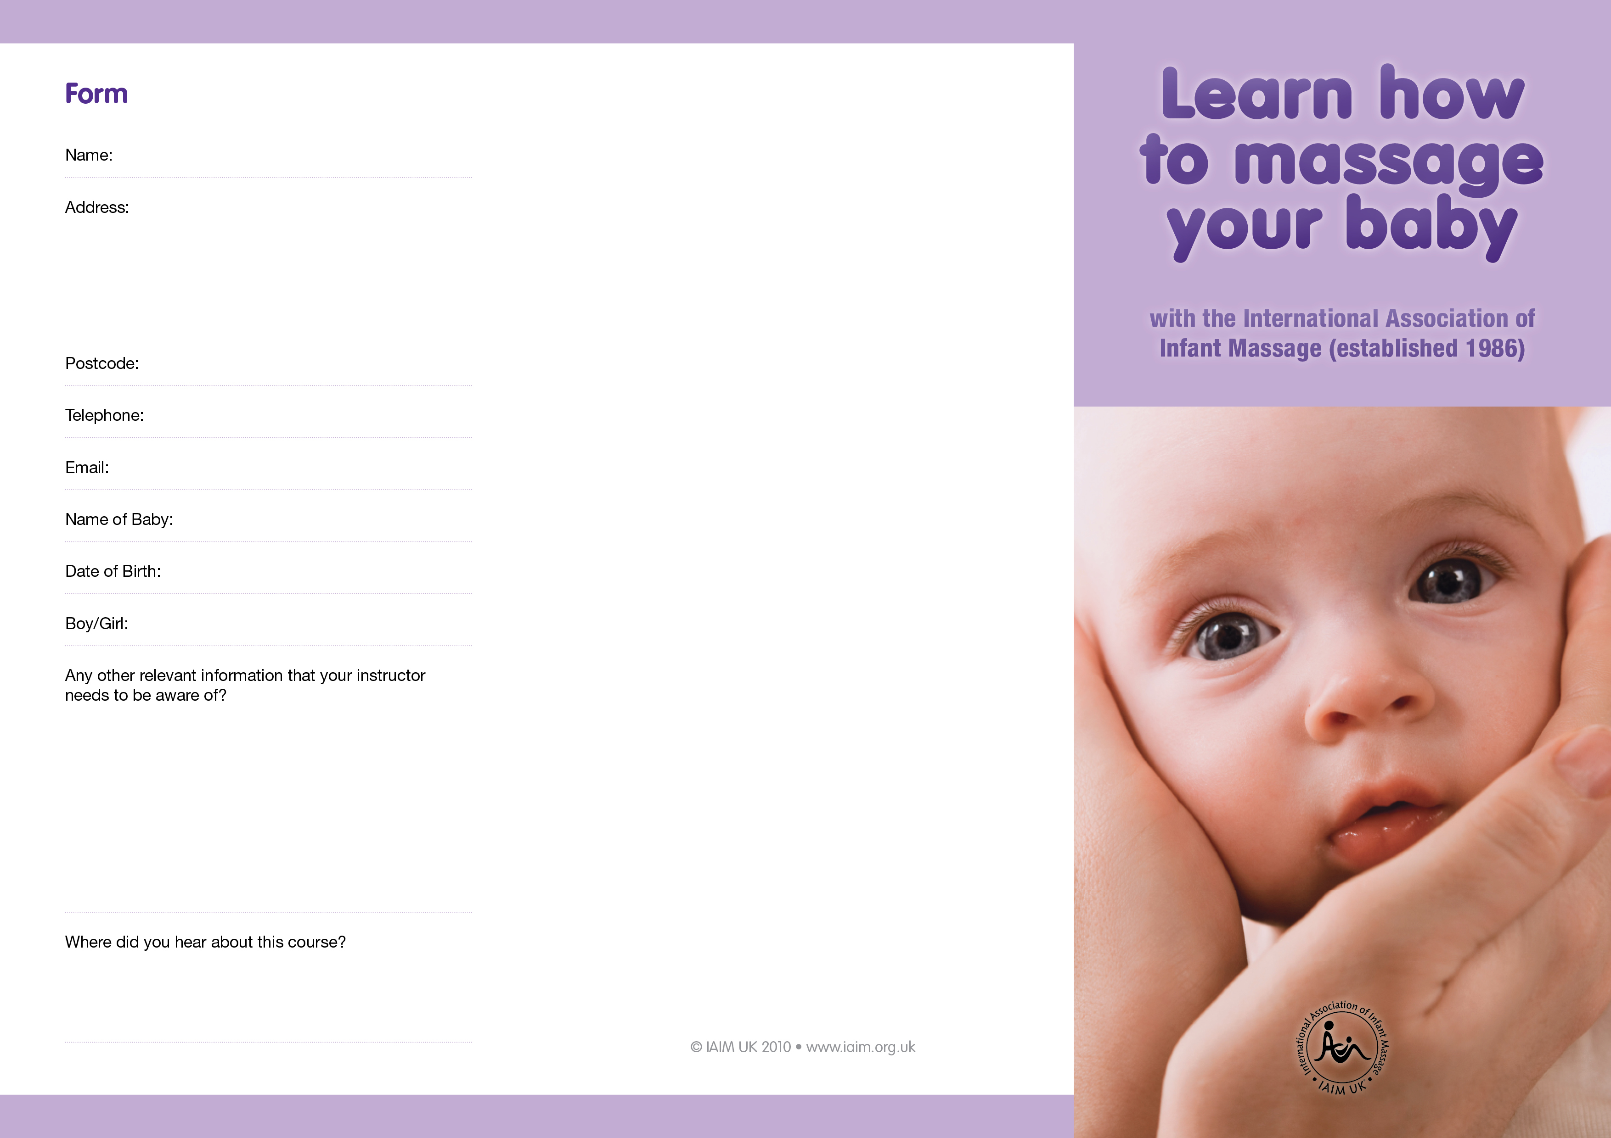
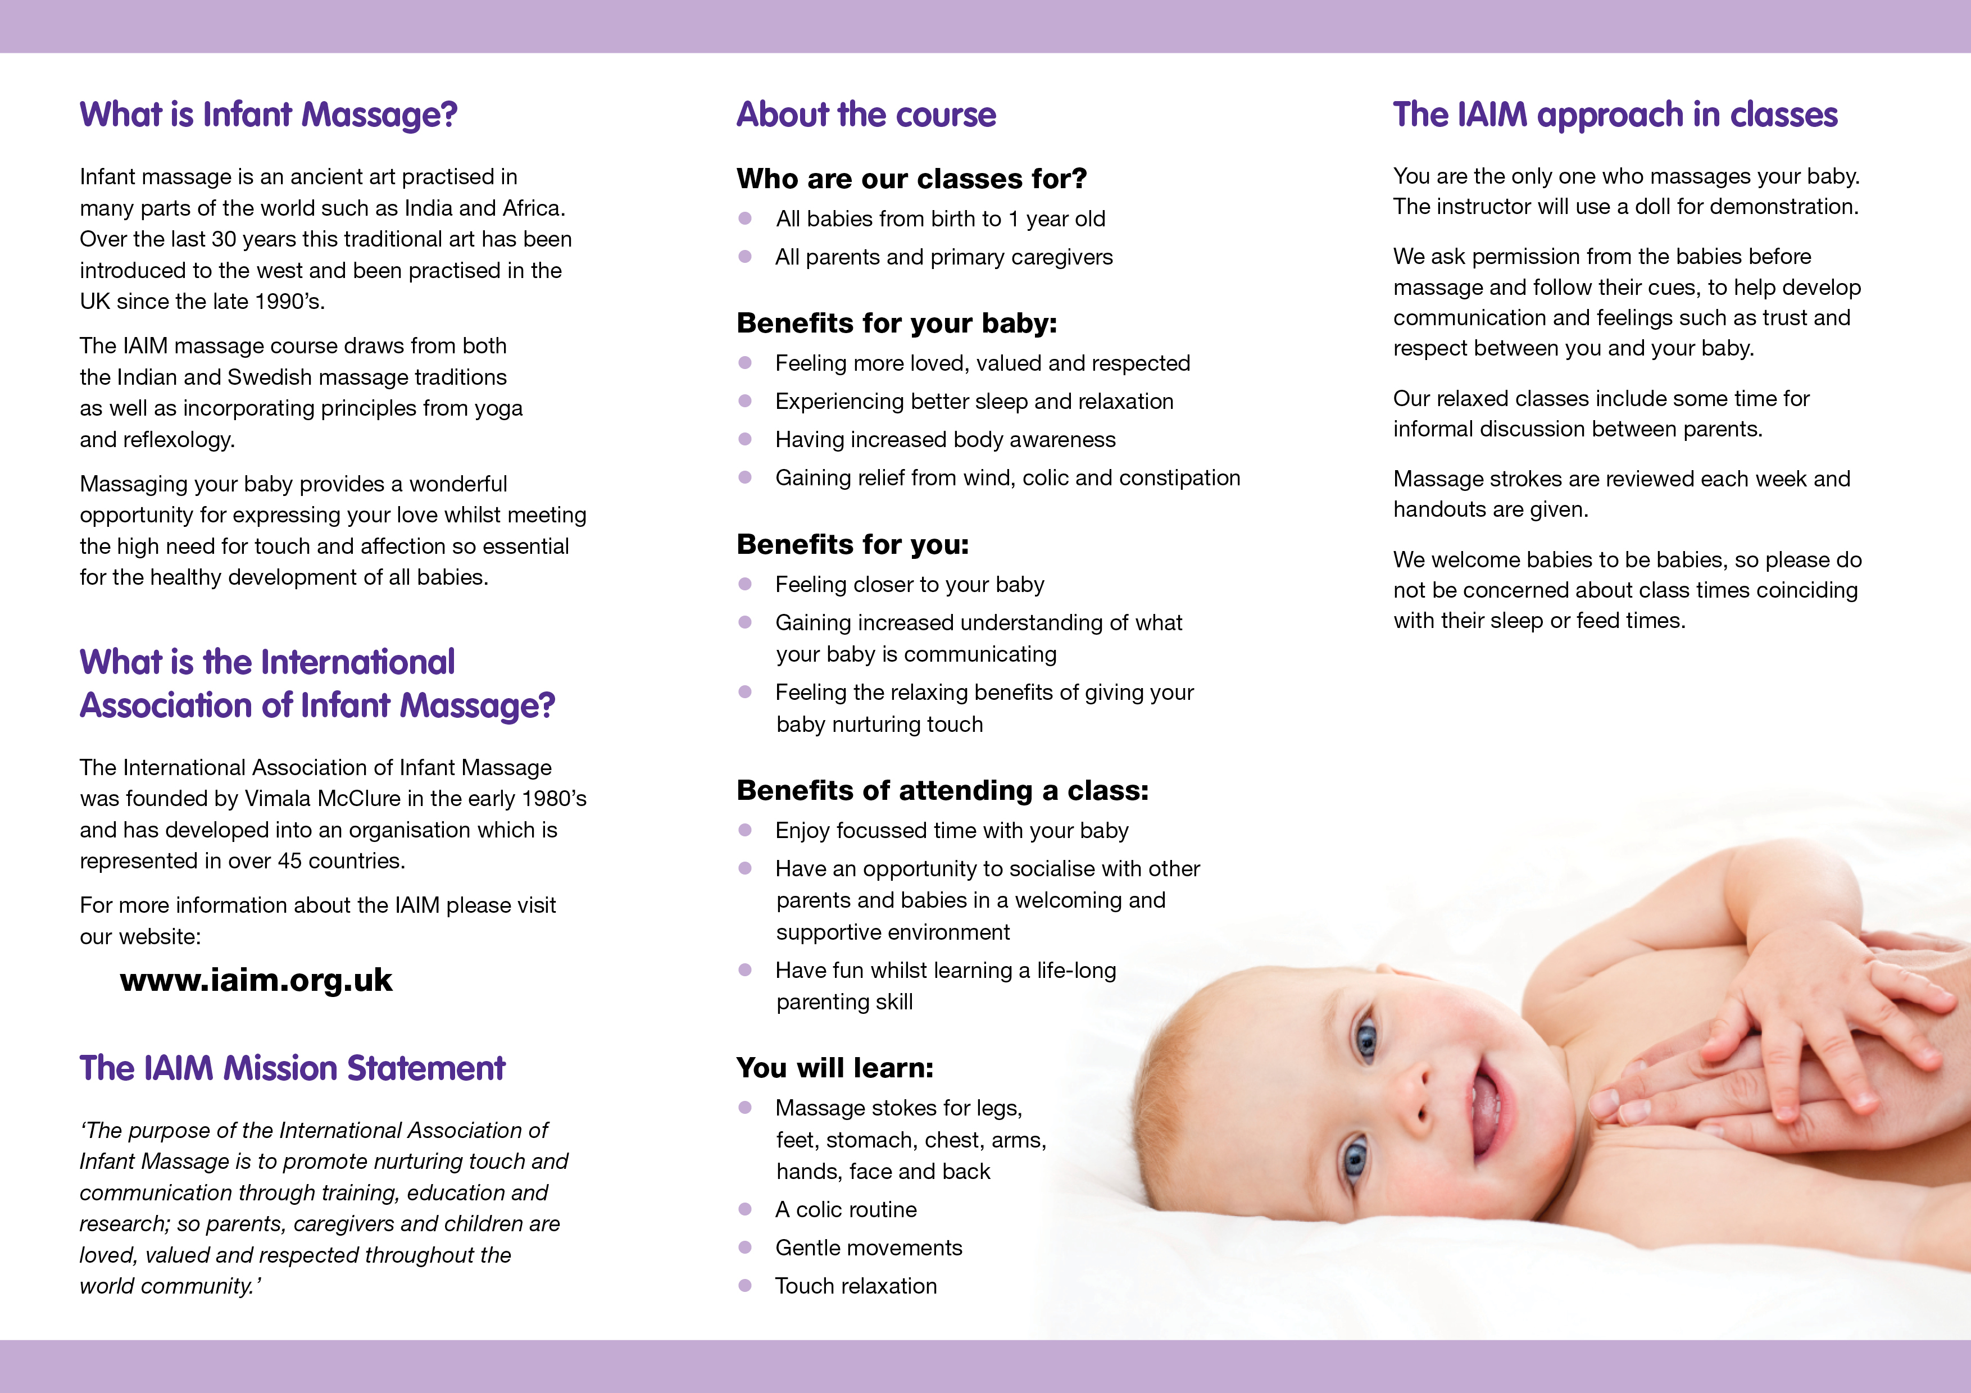
00th Month 2011

